A nicely written description of a crested saguaro taken from the “Eagles Next Living” blog. (website for a home development in Fountain Hills. There is a large crested saguaro at the entrance to the neighborhood.

Crested Saguaro – A Fascinating Deformity on a Majestic Giant
Posted on February 15, 2011 by Jeremy Hall
The magnificent Saguaro Cactus grows only in the 120,000 square mile area of the Sonoran Desert in the southwestern US and northern Mexico. It is arguably one of the most recognized natural wonders of Arizona.
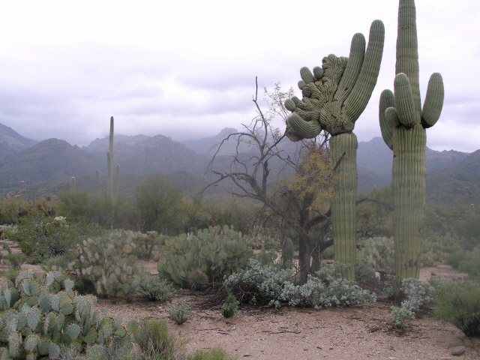
A rare condition that affects roughly one in every 200,000 appears like a fan-like abnormality. These are known as “Crested Saguaros.” The cause of this deformity, which sometimes resembles a burl on trees, is unknown. Theories include everything from lighting strikes to genetic abnormalities. The most widely accepted explanation is that cresting is caused by damage to the apex of the plant, either from some sudden trauma or by freezing. The crest doesn’t seem to harm the saguaro, which can continue to produce flowers and fruit.
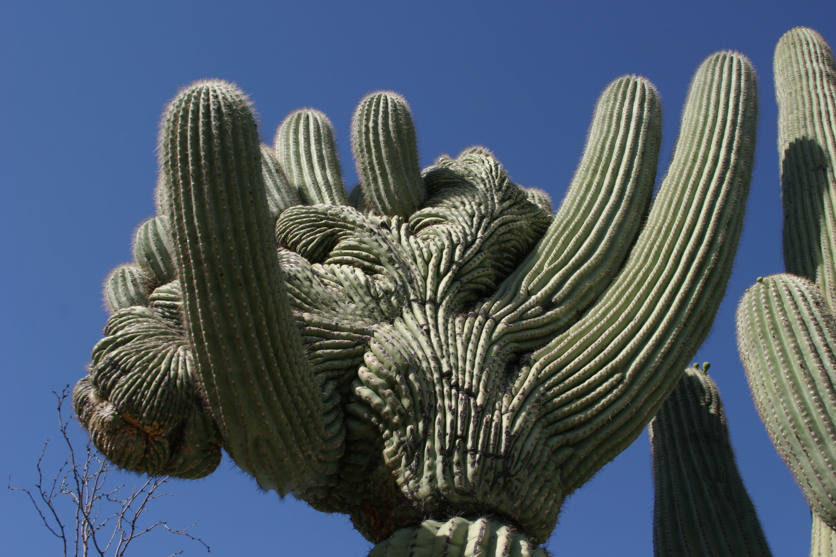
The rarity of this condition has attracted naturalists and other enthusiasts to seek and document them. The Crested Saguaro Society and the Crested Saguaro Collaborative are two such groups. You can find interesting examples at the Desert Botanical Garden in Phoenix and at the Golden Eagle trailhead at Eagles Nest in Fountain Hills, Arizona. Please share your comments about other interesting specimens. © 2011 - Eagles Nest Living Blog
Photos courtesy of Joe Pleggenkuhle and the Crested Saguaro Society

www.crestedsaguarosociety.org

This particular saguaro is located in Sabino Canyon.

